Assignment 3

Emery Dittmer

2023-03-28

#1:Load data

Load the following data: + applications from app_data_sample.parquet + edges from edges_sample.csv

# change to your own path!  
data_path <- "Data/"  
applications <- read_parquet(paste0(data_path,"app_data_sample.parquet"))  
edges <- read_csv(paste0(data_path,"edges_sample.csv"))

## Rows: 32906 Columns: 4  
## ── Column specification ────────────────────────────────────────────────────────  
## Delimiter: ","  
## chr (1): application_number  
## dbl (2): ego_examiner_id, alter_examiner_id  
## date (1): advice_date  
##   
## ℹ Use `spec()` to retrieve the full column specification for this data.  
## ℹ Specify the column types or set `show_col_types = FALSE` to quiet this message.

applications

## # A tibble: 2,018,477 × 16  
## applicat…¹ filing_d…² exami…³ exami…⁴ exami…⁵ exami…⁶ exami…⁷ uspc_…⁸ uspc_…⁹  
## <chr> <date> <chr> <chr> <chr> <dbl> <dbl> <chr> <chr>   
## 1 08284457 2000-01-26 HOWARD JACQUE… V 96082 1764 508 273000   
## 2 08413193 2000-10-11 YILDIR… BEKIR L 87678 1764 208 179000   
## 3 08531853 2000-05-17 HAMILT… CYNTHIA <NA> 63213 1752 430 271100   
## 4 08637752 2001-07-20 MOSHER MARY <NA> 73788 1648 530 388300   
## 5 08682726 2000-04-10 BARR MICHAEL E 77294 1762 427 430100   
## 6 08687412 2000-04-28 GRAY LINDA LAMEY 68606 1734 156 204000   
## 7 08716371 2004-01-26 MCMILL… KARA RENITA 89557 1627 424 401000   
## 8 08765941 2000-06-23 FORD VANESSA L 97543 1645 424 001210   
## 9 08776818 2000-02-04 STRZEL… TERESA E 98714 1637 435 006000   
## 10 08809677 2002-02-20 KIM SUN U 65530 1723 210 645000   
## # … with 2,018,467 more rows, 7 more variables: patent_number <chr>,  
## # patent_issue_date <date>, abandon_date <date>, disposal_type <chr>,  
## # appl_status_code <dbl>, appl_status_date <chr>, tc <dbl>, and abbreviated  
## # variable names ¹​application_number, ²​filing_date, ³​examiner_name_last,  
## # ⁴​examiner_name_first, ⁵​examiner_name_middle, ⁶​examiner_id,  
## # ⁷​examiner_art_unit, ⁸​uspc_class, ⁹​uspc_subclass

edges

## # A tibble: 32,906 × 4  
## application_number advice_date ego_examiner_id alter_examiner_id  
## <chr> <date> <dbl> <dbl>  
## 1 09402488 2008-11-17 84356 66266  
## 2 09402488 2008-11-17 84356 63519  
## 3 09402488 2008-11-17 84356 98531  
## 4 09445135 2008-08-21 92953 71313  
## 5 09445135 2008-08-21 92953 93865  
## 6 09445135 2008-08-21 92953 91818  
## 7 09479304 2008-12-15 61767 69277  
## 8 09479304 2008-12-15 61767 92446  
## 9 09479304 2008-12-15 61767 66805  
## 10 09479304 2008-12-15 61767 70919  
## # … with 32,896 more rows

## Get gender for examiners

We’ll get gender based on the first name of the examiner, which is recorded in the field examiner_name_first. We’ll use library gender for that, relying on a modified version of their own [example](https://cran.r-project.org/web/packages/gender/vignettes/predicting-gender.html).

Note that there are over 2 million records in the applications table – that’s because there are many records for each examiner, as many as the number of applications that examiner worked on during this time frame. Our first step therefore is to get all *unique* names in a separate list examiner_names. We will then guess gender for each one and will join this table back to the original dataset. So, let’s get names without repetition:

library(gender)  
#install_genderdata_package() # only run this line the first time you use the package, to get data for it  
# get a list of first names without repetitions  
examiner_names <- applications %>%   
 distinct(examiner_name_first)  
examiner_names

## # A tibble: 2,595 × 1  
## examiner_name_first  
## <chr>   
## 1 JACQUELINE   
## 2 BEKIR   
## 3 CYNTHIA   
## 4 MARY   
## 5 MICHAEL   
## 6 LINDA   
## 7 KARA   
## 8 VANESSA   
## 9 TERESA   
## 10 SUN   
## # … with 2,585 more rows

Now let’s use function gender() as shown in the example for the package to attach a gender and probability to each name and put the results into the table examiner_names_gender

# get a table of names and gender  
examiner_names_gender <- examiner_names %>%   
 do(results = gender(.$examiner_name_first, method = "ssa")) %>%   
 unnest(cols = c(results), keep_empty = TRUE) %>%   
 select(  
 examiner_name_first = name,  
 gender,  
 proportion_female  
 )  
examiner_names_gender

## # A tibble: 1,822 × 3  
## examiner_name_first gender proportion_female  
## <chr> <chr> <dbl>  
## 1 AARON male 0.0082  
## 2 ABDEL male 0   
## 3 ABDOU male 0   
## 4 ABDUL male 0   
## 5 ABDULHAKIM male 0   
## 6 ABDULLAH male 0   
## 7 ABDULLAHI male 0   
## 8 ABIGAIL female 0.998   
## 9 ABIMBOLA female 0.944   
## 10 ABRAHAM male 0.0031  
## # … with 1,812 more rows

Finally, let’s join that table back to our original applications data and discard the temporary tables we have just created to reduce clutter in our environment.

# remove extra colums from the gender table  
examiner_names_gender <- examiner_names_gender %>%   
 select(examiner_name_first, gender)  
# joining gender back to the dataset  
applications <- applications %>%   
 left_join(examiner_names_gender, by = "examiner_name_first")  
# cleaning up  
rm(examiner_names)  
rm(examiner_names_gender)  
gc()

## used (Mb) gc trigger (Mb) max used (Mb)  
## Ncells 4662327 249.0 8223900 439.3 5106618 272.8  
## Vcells 49868964 380.5 93038134 709.9 80184719 611.8

## Guess the examiner’s race

We’ll now use package wru to estimate likely race of an examiner. Just like with gender, we’ll get a list of unique names first, only now we are using surnames.

library(wru)  
examiner_surnames <- applications %>%   
 select(surname = examiner_name_last) %>%   
 distinct()  
examiner_surnames

## # A tibble: 3,806 × 1  
## surname   
## <chr>   
## 1 HOWARD   
## 2 YILDIRIM   
## 3 HAMILTON   
## 4 MOSHER   
## 5 BARR   
## 6 GRAY   
## 7 MCMILLIAN   
## 8 FORD   
## 9 STRZELECKA  
## 10 KIM   
## # … with 3,796 more rows

We’ll follow the instructions for the package outlined here <https://github.com/kosukeimai/wru>.

examiner_race <- predict_race(voter.file = examiner_surnames, surname.only = T) %>%   
 as_tibble()

## Warning: Unknown or uninitialised column: `state`.

## Proceeding with last name predictions...

## ℹ All local files already up-to-date!

## 701 (18.4%) individuals' last names were not matched.

examiner_race

## # A tibble: 3,806 × 6  
## surname pred.whi pred.bla pred.his pred.asi pred.oth  
## <chr> <dbl> <dbl> <dbl> <dbl> <dbl>  
## 1 HOWARD 0.597 0.295 0.0275 0.00690 0.0741  
## 2 YILDIRIM 0.807 0.0273 0.0694 0.0165 0.0798  
## 3 HAMILTON 0.656 0.239 0.0286 0.00750 0.0692  
## 4 MOSHER 0.915 0.00425 0.0291 0.00917 0.0427  
## 5 BARR 0.784 0.120 0.0268 0.00830 0.0615  
## 6 GRAY 0.640 0.252 0.0281 0.00748 0.0724  
## 7 MCMILLIAN 0.322 0.554 0.0212 0.00340 0.0995  
## 8 FORD 0.576 0.320 0.0275 0.00621 0.0697  
## 9 STRZELECKA 0.472 0.171 0.220 0.0825 0.0543  
## 10 KIM 0.0169 0.00282 0.00546 0.943 0.0319  
## # … with 3,796 more rows

write.csv(examiner_race, "examiner_race.csv", row.names=FALSE)

As you can see, we get probabilities across five broad US Census categories: white, black, Hispanic, Asian and other. (Some of you may correctly point out that Hispanic is not a race category in the US Census, but these are the limitations of this package.)

Our final step here is to pick the race category that has the highest probability for each last name and then join the table back to the main applications table. See this example for comparing values across columns: <https://www.tidyverse.org/blog/2020/04/dplyr-1-0-0-rowwise/>. And this one for case_when() function: <https://dplyr.tidyverse.org/reference/case_when.html>.

examiner_race <- examiner_race %>%   
 mutate(max_race_p = pmax(pred.asi, pred.bla, pred.his, pred.oth, pred.whi)) %>%   
 mutate(race = case_when(  
 max_race_p == pred.asi ~ "Asian",  
 max_race_p == pred.bla ~ "black",  
 max_race_p == pred.his ~ "Hispanic",  
 max_race_p == pred.oth ~ "other",  
 max_race_p == pred.whi ~ "white",  
 TRUE ~ NA_character_  
 ))  
examiner_race

## # A tibble: 3,806 × 8  
## surname pred.whi pred.bla pred.his pred.asi pred.oth max_race_p race   
## <chr> <dbl> <dbl> <dbl> <dbl> <dbl> <dbl> <chr>  
## 1 HOWARD 0.597 0.295 0.0275 0.00690 0.0741 0.597 white  
## 2 YILDIRIM 0.807 0.0273 0.0694 0.0165 0.0798 0.807 white  
## 3 HAMILTON 0.656 0.239 0.0286 0.00750 0.0692 0.656 white  
## 4 MOSHER 0.915 0.00425 0.0291 0.00917 0.0427 0.915 white  
## 5 BARR 0.784 0.120 0.0268 0.00830 0.0615 0.784 white  
## 6 GRAY 0.640 0.252 0.0281 0.00748 0.0724 0.640 white  
## 7 MCMILLIAN 0.322 0.554 0.0212 0.00340 0.0995 0.554 black  
## 8 FORD 0.576 0.320 0.0275 0.00621 0.0697 0.576 white  
## 9 STRZELECKA 0.472 0.171 0.220 0.0825 0.0543 0.472 white  
## 10 KIM 0.0169 0.00282 0.00546 0.943 0.0319 0.943 Asian  
## # … with 3,796 more rows

Let’s join the data back to the applications table.

# removing extra columns  
examiner_race <- examiner_race %>%   
 select(surname,race)  
applications <- applications %>%   
 left_join(examiner_race, by = c("examiner_name_last" = "surname"))  
rm(examiner_race)  
rm(examiner_surnames)  
gc()

## used (Mb) gc trigger (Mb) max used (Mb)  
## Ncells 4797280 256.3 8223900 439.3 8223900 439.3  
## Vcells 54203029 413.6 111725760 852.4 92948874 709.2

#2. Focus on Art Unit:Descriptive Stats ## Work Unit Breakdown of people

We will compare genders and ethnicity across all work units within the US Patent office. First let’s do some descriptive statistics on the overall population.

Lets keep only one observation per person for the data since once person could count twice for a work group

person_level_data <- applications %>%   
 group_by(examiner_id) %>%   
 summarise(  
 art_unit = min(examiner_art_unit, na.rm = TRUE),  
 gender = min(gender, na.rm = TRUE),  
 race = min(race,na.rm=TRUE)) %>%  
 mutate(  
 tc = floor(art_unit/100)*100,  
 work_group = as.factor(floor(art_unit/10)*10)  
 ) %>%   
 filter(!is.na(gender) & !is.na(race)) # dropping all records where we don't know the gender  
person_level_data

## # A tibble: 4,849 × 6  
## examiner_id art_unit gender race tc work_group  
## <dbl> <dbl> <chr> <chr> <dbl> <fct>   
## 1 59012 1716 male white 1700 1710   
## 2 59025 2465 male Asian 2400 2460   
## 3 59040 1724 female Asian 1700 1720   
## 4 59052 2138 male Asian 2100 2130   
## 5 59055 2165 male Asian 2100 2160   
## 6 59056 2124 male Asian 2100 2120   
## 7 59081 2489 male Asian 2400 2480   
## 8 59086 2487 female white 2400 2480   
## 9 59096 1612 male white 1600 1610   
## 10 59117 2439 male white 2400 2430   
## # … with 4,839 more rows

#grouping by work unit  
work_unit_level_data <-person_level_data %>%  
 group_by(work_group,race,gender) %>%  
 summarize(  
 n=n()  
 )

## `summarise()` has grouped output by 'work_group', 'race'. You can override  
## using the `.groups` argument.

work_unit_level_data

## # A tibble: 263 × 4  
## # Groups: work_group, race [146]  
## work_group race gender n  
## <fct> <chr> <chr> <int>  
## 1 1600 Asian female 3  
## 2 1600 black female 1  
## 3 1600 white female 13  
## 4 1600 white male 18  
## 5 1610 Asian female 18  
## 6 1610 Asian male 15  
## 7 1610 black female 4  
## 8 1610 black male 2  
## 9 1610 Hispanic female 2  
## 10 1610 Hispanic male 3  
## # … with 253 more rows

#we will also need to aggregated by total number of people in work_unit  
work_unit_aggregated <- work_unit_level_data %>%  
 group_by(work_group) %>%  
 summarize(  
 n=sum(n)  
 ) %>%  
 arrange (desc(n))  
work_unit_aggregated

## # A tibble: 38 × 2  
## work_group n  
## <fct> <int>  
## 1 2130 237  
## 2 1610 226  
## 3 2150 226  
## 4 1720 225  
## 5 2120 210  
## 6 1710 208  
## 7 1630 207  
## 8 2410 203  
## 9 2160 197  
## 10 1770 189  
## # … with 28 more rows

Let’s plot the race, and gender as a function of workgroup. First looking at counts then distributions

library(ggplot2)  
ggplot(work_unit_level_data) +  
 geom_boxplot(aes(x = work_group, color = gender))

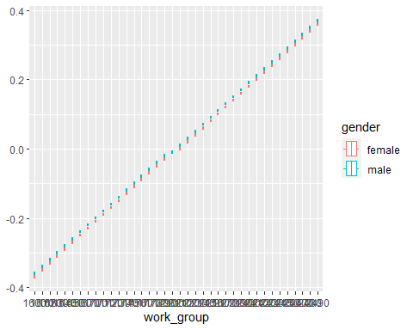

ggplot(work_unit_level_data,aes(x = work_group, color = gender, y=n)) +  
 geom_bar(stat="identity", position=position_dodge())

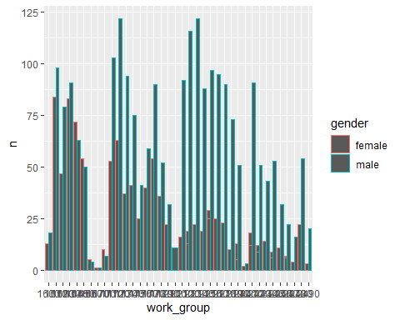

Let’s plot for the top 5 work groups to make it easier to read. First we will look at the number (counts) then we will look at the distributions using box plots.

work_unit_level_data_top5 <- work_unit_level_data %>%  
 filter(work_group %in% head(work_unit_aggregated$work_group,5))  
  
ggplot(work_unit_level_data_top5,aes(x = work_group, y=n)) +  
 geom_bar(stat="identity", position=position_dodge())

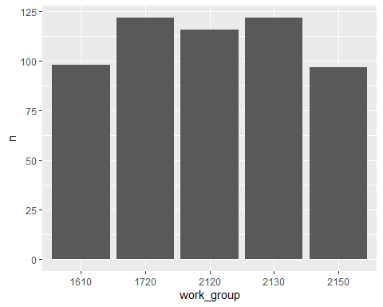

ggplot(work_unit_level_data_top5,aes(x = work_group, fill = gender, y=n)) +  
 geom_bar(stat="identity", position=position_dodge())

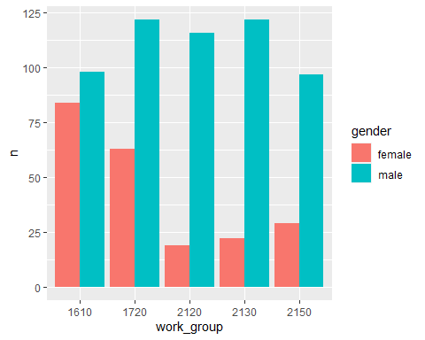

ggplot(work_unit_level_data_top5,aes(x = work_group, fill = gender, y=n)) +  
 geom_bar(stat="identity", position=position_dodge())+  
 facet_wrap(~race)

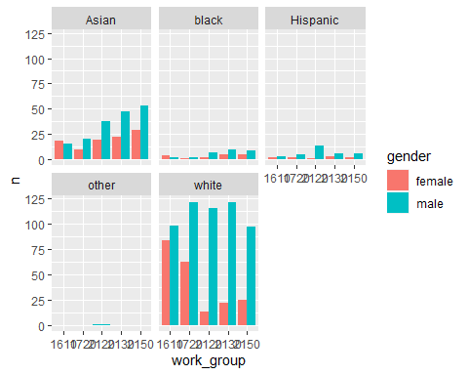

#   
# ggplot(work_unit_level_data_top5) +  
# geom_boxplot(aes(x = (work_group),y=n, color = gender))  
#   
# ggplot(work_unit_level_data_top5) +  
# geom_boxplot(aes(x = (work_group),y=n, color = gender))+  
# facet_wrap(~race)  
remove(work_unit_level_data_top5)

Even the top 5 is alot of data. For the remaining analysis we will focus on the top 2 work_units: 2130 and 1610. Since we are only using 2 art units the ditribution is not as relenvant to plot at the moment.

work_unit_level_data_top2 <- work_unit_level_data %>%  
 filter(work_group %in% head(work_unit_aggregated$work_group,2))  
  
ggplot(work_unit_level_data_top2,aes(x = work_group, y=n)) +  
 geom_bar(stat="identity", position=position_dodge())

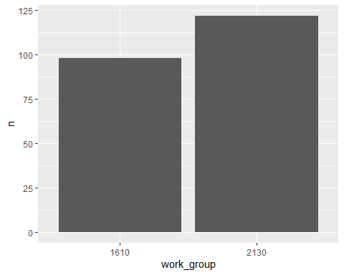

ggplot(work_unit_level_data_top2,aes(x = work_group, fill = gender, y=n)) +  
 geom_bar(stat="identity", position=position_dodge())

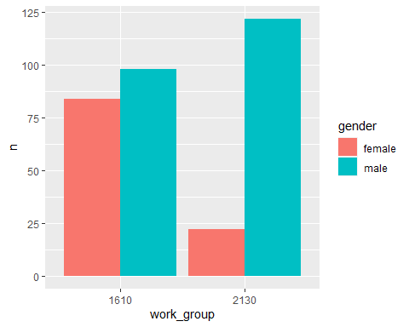

ggplot(work_unit_level_data_top2,aes(x = work_group, fill = gender, y=n)) +  
 geom_bar(stat="identity", position=position_dodge())+  
 facet_wrap(~race)

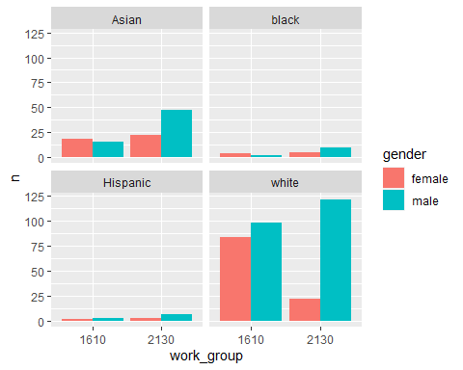

# ggplot(work_unit_level_data_top2) +  
# geom_boxplot(aes(x = (work_group),y=n, color = gender))

subset_app_data <- person_level_data %>%   
 #here we make sure on ly the top 2 work groups are picked  
 filter(work_group %in% head(work_unit_aggregated$work_group,2)) %>%   
 mutate(race = race, gender =gender) %>%   
 select(gender, race, work_group)

## Gender

let’s investigate gender, first accros borht work groups then within the workgroup

subset_app_data %>%   
 count(gender) %>%   
 mutate(pct = n/sum(n))

## # A tibble: 2 × 3  
## gender n pct  
## <chr> <int> <dbl>  
## 1 female 160 0.346  
## 2 male 303 0.654

subset_app_data %>%   
 group_by(work_group) %>%  
 count(gender) %>%   
 mutate(pct = n/sum(n))

## # A tibble: 4 × 4  
## # Groups: work_group [2]  
## work_group gender n pct  
## <fct> <chr> <int> <dbl>  
## 1 1610 female 108 0.478  
## 2 1610 male 118 0.522  
## 3 2130 female 52 0.219  
## 4 2130 male 185 0.781

## Race

let’s investigate race with the same process as above, first accros borht work groups then within the workgroup

subset_app_data %>%  
 group_by(work_group) %>%  
 count(race) %>%   
 mutate(pct = n/sum(n))

## # A tibble: 8 × 4  
## # Groups: work_group [2]  
## work_group race n pct  
## <fct> <chr> <int> <dbl>  
## 1 1610 Asian 33 0.146   
## 2 1610 black 6 0.0265  
## 3 1610 Hispanic 5 0.0221  
## 4 1610 white 182 0.805   
## 5 2130 Asian 69 0.291   
## 6 2130 black 15 0.0633  
## 7 2130 Hispanic 9 0.0380  
## 8 2130 white 144 0.608

## Puttin it together

Let’s investgate both at the same time

library(webr)  
PieDonut(subset_app_data, aes(gender,race), title = "USPTO Work Units 2130 & 1610 by gender and ethnicity")

## Warning: The `<scale>` argument of `guides()` cannot be `FALSE`. Use "none" instead as  
## of ggplot2 3.3.4.  
## ℹ The deprecated feature was likely used in the webr package.  
## Please report the issue at <]8;;https://github.com/cardiomoon/webr/issueshttps://github.com/cardiomoon/webr/issues]8;;>.

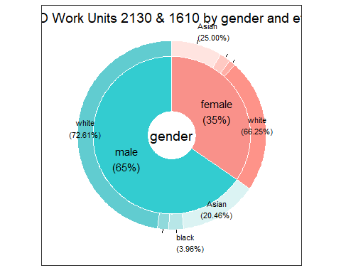

subset_app_data1 <- subset_app_data %>% filter(work_group==2130)  
subset_app_data2 <- subset_app_data %>% filter(work_group==1610)  
  
PieDonut(subset_app_data1, aes(gender,race), title = "USPTO Work Group 2130 breakown by gender and ethnicity", explodeDonut=TRUE)

## Warning in geom_arc_bar(aes_string(x0 = "x", y0 = "y", r0 = as.character(r1), :  
## Ignoring unknown aesthetics: explode

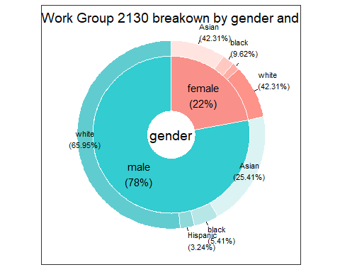

PieDonut(subset_app_data2, aes(gender,race), title = "USPTO Work Group 1610 breakown by gender and ethnicity", explodeDonut=TRUE)

## Warning in geom_arc_bar(aes_string(x0 = "x", y0 = "y", r0 = as.character(r1), :  
## Ignoring unknown aesthetics: explode

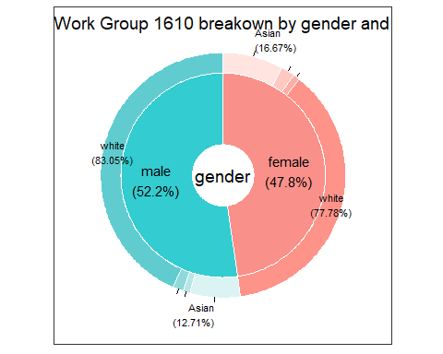

remove(subset_app_data1, subset_app_data2)

#3: Advice Network ##Nodes & Edges First we need to subset the data and remove the examiners who are not in the work groups we are looking at

#copy data in case  
edges_full <- edges  
edges <- edges_full  
  
subset_exam_id <- person_level_data %>%  
 filter(work_group %in% head(work_unit_aggregated$work_group,2)) %>%  
 select(examiner_id,work_group) %>%  
 drop_na()  
  
#crete the edges  
edges <- edges %>%  
 filter(ego_examiner_id %in% subset_exam_id$examiner_id)%>%  
 drop_na() %>%  
 mutate(from=ego_examiner_id,to=alter_examiner_id) %>%  
 select(from, to)  
  
#create the nodes  
#many issues with nodes will try pulling from edges list  
# nodes_all <- unique(select(edges_full, ego_examiner_id)) %>%  
# mutate(id=ego_examiner_id, verticies =ego_examiner_id) %>%  
# select(id,verticies) %>%  
# drop_na  
  
nodes_all <-as.data.frame(do.call(rbind,append(as.list(edges$from),as.list(edges$to))))  
  
nodes_all <- nodes_all %>%  
 mutate(id=V1) %>%  
 select(id) %>%  
 distinct(id) %>%  
 drop_na()  
nodes <- nodes_all  
# nodes <- nodes_all %>%  
# mutate(label=as.character(ego_examiner_id)) %>%  
# filter(id %in% edges$from | id %in% edges$to ) %>%  
# drop_na() %>%  
# select(id,label)

library(visNetwork)  
visNetwork(nodes, edges)%>%  
 visLegend() %>%  
 visEdges(arrows ="to")%>%  
 visEdges(arrows ="from")



Based on this data we will only have about 121 employees in the work groups we are interested in

### 3.1 Degree Centrality

The count of the number of links each node has to other nodes. For instance, seat A(labelled as 3 above) has a degree centrality of 3 since it is connected to 3 other nodes: 2, B & C (B labelled as 4 and C labelled as 5 above)

We can validate this with the igraph package wich has a built in functionality for centrality degree

library(igraph)

##   
## Attaching package: 'igraph'

## The following objects are masked from 'package:lubridate':  
##   
## %--%, union

## The following objects are masked from 'package:dplyr':  
##   
## as_data_frame, groups, union

## The following objects are masked from 'package:purrr':  
##   
## compose, simplify

## The following object is masked from 'package:tidyr':  
##   
## crossing

## The following object is masked from 'package:tibble':  
##   
## as_data_frame

## The following objects are masked from 'package:stats':  
##   
## decompose, spectrum

## The following object is masked from 'package:base':  
##   
## union

library(tidygraph)

##   
## Attaching package: 'tidygraph'

## The following object is masked from 'package:igraph':  
##   
## groups

## The following object is masked from 'package:stats':  
##   
## filter

library(tidyverse)  
  
g <- igraph::graph_from_data_frame(edges, vertices = nodes) %>% as_tbl_graph(directed=TRUE)  
#not sure why this isnt working  
#g = tbl_graph(nodes = nodes, edges = edges, directed = FALSE)  
g <- g %>%   
 activate(nodes) %>%   
 mutate(degree = centrality_degree()) %>%   
 activate(edges)  
  
tg_nodes <-  
 g %>%  
 activate(nodes) %>%  
 data.frame() %>%  
 arrange(desc(degree)) %>%  
 rename(Centrality_Degree=degree) %>%  
 mutate(name=as.integer(name))  
  
nodes_all <- nodes_all %>%  
 left_join(tg_nodes,by=c("id"="name"))   
  
remove(g,tg_nodes)

There is agreement between our calculations and the calculations for the package therefore we can use them!

### 3.2 Closeness centrality

A measure that calculates the ability to spread information efficiently via the edges the node is connected to. It is calculated as the inverse of the average shortest path between nodes.

For instance, for node A (labelled 3), the closeness is 1/((1+2+1+1+2+2+2+2+3))=0.0625. The higher the number, the closer the node is to the center based on distance. See appendix For details

g <- igraph::graph_from_data_frame(edges, vertices = nodes) %>% as_tbl_graph(directed=TRUE)  
  
g <- g %>%   
 activate(nodes) %>%   
 mutate(degree = centrality_closeness()) %>%   
 activate(edges)  
  
tg_nodes <-  
 g %>%  
 activate(nodes) %>%  
 data.frame() %>%  
 arrange(desc(degree)) %>%  
 rename(Centrality_Closeness=degree) %>%  
 mutate(name=as.integer(name))  
  
nodes_all <- nodes_all %>%  
 left_join(tg_nodes,by=c("id"="name"))   
remove(g,tg_nodes)

### 3.3 Betweenness centrality

A measure that detects a node’s influence over the flow of information within a graph. This is the sum of the shortest paths between two points i and j divided by the number of shortest paths that pass-through node v.

g <- igraph::graph_from_data_frame(edges, vertices = nodes) %>% as_tbl_graph(directed=TRUE)  
  
g <- g %>%   
 activate(nodes) %>%   
 mutate(degree = centrality_betweenness()) %>%   
 activate(edges)  
  
tg_nodes <-  
 g %>%  
 activate(nodes) %>%  
 data.frame() %>%  
 arrange(desc(degree)) %>%  
 rename(Centrality_Betweenness=degree) %>%  
 mutate(name=as.integer(name))  
  
nodes_all <- nodes_all %>%  
 left_join(tg_nodes,by=c("id"="name"))   
remove(g,tg_nodes)

## Visualize all together

LEt’s put all the data together now!

nodes <- nodes_all %>%   
 left_join(subset_exam_id,by=c("id"="examiner_id")) %>%  
 mutate(label = paste("Examiner:",id,"\n",  
 "Centrality Degre:",format(Centrality_Degree, digits = 2),"\n",  
 "Closenness:",format(Centrality_Closeness, digits = 2),"\n",  
 "Betweenness:",format(Centrality_Betweenness, digits = 2),"\n",  
 sep = " "),  
 group=work_group) %>%  
 mutate(font.size = 12) %>%  
 drop_na()  
  
visNetwork(nodes, edges)%>%  
 visLegend() %>%  
 visEdges(arrows ="to")%>%  
 visEdges(arrows ="from")

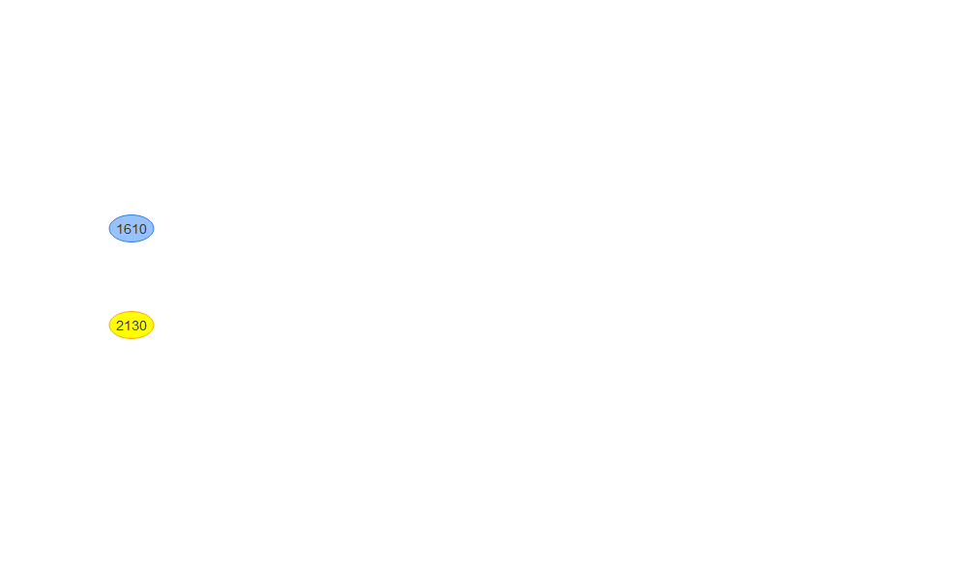

## Igraph version

labels must be removed for igraph or else it does not work well.

net <- igraph::graph_from_data_frame(edges, vertices = nodes_all) %>% as_tbl_graph(directed=TRUE)  
plot(net, edge.arrow.size=.4,vertex.label=NA,vertex.size=4)

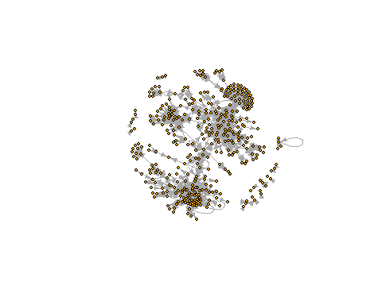

plot(net, edge.arrow.size=.4,vertex.label.cex=.4,vertex.label.dist=1,vertex.size=4)

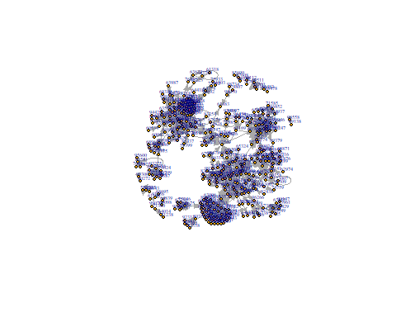

## Now to look at measures of centrality accross ethnicities and genders

#join race and gender data to nodes  
library(gt)  
nodes <- nodes %>%  
 left_join(person_level_data,by=c("id"="examiner_id","work_group"="work_group" ))  
  
ggplot(nodes) +  
 geom_bar(aes(x = work_group))

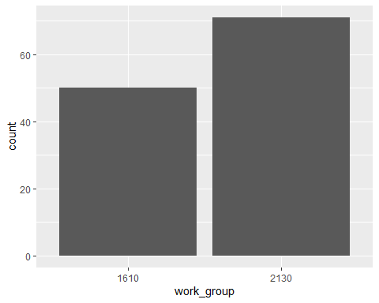

ggplot(nodes) +  
 geom_bar(aes(x = work_group ,fill=gender))

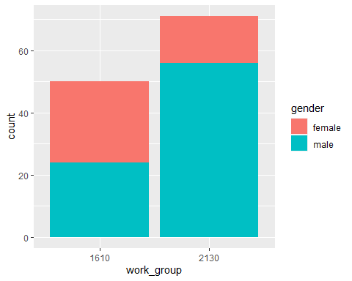

ggplot(nodes) +  
 geom_bar(aes(x = work_group ,fill=race))

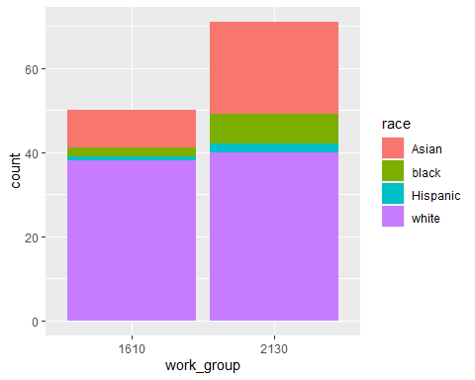

nodes %>%   
 group_by(work_group) %>%  
 count(work_group) %>%   
 mutate(pct_within_work_group = round(n/sum(n)*100,0)) %>% gt()

| n | pct_within_work_group |
| --- | --- |
| 1610 |
| 50 | 100 |
| 2130 |
| 71 | 100 |

nodes %>%   
 group_by(work_group) %>%  
 count(gender) %>%   
 mutate(pct_within_work_group = round(n/sum(n)*100,0)) %>% gt()

| gender | n | pct_within_work_group |
| --- | --- | --- |
| 1610 |
| female | 26 | 52 |
| male | 24 | 48 |
| 2130 |
| female | 15 | 21 |
| male | 56 | 79 |

nodes %>%   
 group_by(work_group) %>%  
 count(race) %>%   
 mutate(pct_within_work_group = round(n/sum(n)*100,0)) %>% gt()

| race | n | pct_within_work_group |
| --- | --- | --- |
| 1610 |
| Asian | 9 | 18 |
| black | 2 | 4 |
| Hispanic | 1 | 2 |
| white | 38 | 76 |
| 2130 |
| Asian | 22 | 31 |
| black | 7 | 10 |
| Hispanic | 2 | 3 |
| white | 40 | 56 |

nodes %>%   
 group_by(work_group) %>%  
 summarize(  
 Sum_of_Centrality_Degree=sum(Centrality_Degree),  
 Sum_of_Centrality_Closeness=sum(Centrality_Closeness),  
 Sum_of_Centrality_Betweenness=sum(Centrality_Betweenness),  
 Count=n()  
 ) %>% gt()

| work_group | Sum_of_Centrality_Degree | Sum_of_Centrality_Closeness | Sum_of_Centrality_Betweenness | Count |
| --- | --- | --- | --- | --- |
| 1610 | 579 | 21.77945 | 124 | 50 |
| 2130 | 566 | 24.99051 | 164 | 71 |

nodes %>%   
 group_by(gender) %>%  
 summarize(  
 Sum_of_Centrality_Degree=sum(Centrality_Degree),  
 Sum_of_Centrality_Closeness=sum(Centrality_Closeness),  
 Sum_of_Centrality_Betweenness=sum(Centrality_Betweenness),  
 Count=n()  
 ) %>% gt()

| gender | Sum_of_Centrality_Degree | Sum_of_Centrality_Closeness | Sum_of_Centrality_Betweenness | Count |
| --- | --- | --- | --- | --- |
| female | 442 | 15.66323 | 102.1905 | 41 |
| male | 703 | 31.10673 | 185.8095 | 80 |

nodes %>%   
 group_by(race) %>%  
 summarize(  
 Sum_of_Centrality_Degree=sum(Centrality_Degree),  
 Sum_of_Centrality_Closeness=sum(Centrality_Closeness),  
 Sum_of_Centrality_Betweenness=sum(Centrality_Betweenness),  
 Count=n()  
 ) %>% gt()

| race | Sum_of_Centrality_Degree | Sum_of_Centrality_Closeness | Sum_of_Centrality_Betweenness | Count |
| --- | --- | --- | --- | --- |
| Asian | 360 | 12.330561 | 72.66667 | 31 |
| black | 47 | 4.922756 | 1.00000 | 9 |
| Hispanic | 55 | 1.375000 | 51.14286 | 3 |
| white | 683 | 28.141638 | 163.19048 | 78 |

nodes %>%   
 group_by(work_group,race) %>%  
 summarize(  
 Sum_of_Centrality_Degree=sum(Centrality_Degree),  
 Sum_of_Centrality_Closeness=sum(Centrality_Closeness),  
 Sum_of_Centrality_Betweenness=sum(Centrality_Betweenness),  
 Count=n()  
 ) %>% gt()

## `summarise()` has grouped output by 'work_group'. You can override using the  
## `.groups` argument.

| race | Sum_of_Centrality_Degree | Sum_of_Centrality_Closeness | Sum_of_Centrality_Betweenness | Count |
| --- | --- | --- | --- | --- |
| 1610 |
| Asian | 111 | 5.27777778 | 6.666667 | 9 |
| black | 3 | 1.50000000 | 0.000000 | 2 |
| Hispanic | 51 | 0.04166667 | 46.142857 | 1 |
| white | 414 | 14.96000602 | 71.190476 | 38 |
| 2130 |
| Asian | 249 | 7.05278347 | 66.000000 | 22 |
| black | 44 | 3.42275641 | 1.000000 | 7 |
| Hispanic | 4 | 1.33333333 | 5.000000 | 2 |
| white | 269 | 13.18163211 | 92.000000 | 40 |

nodes %>%   
 group_by(race,gender) %>%  
 summarize(  
 Sum_of_Centrality_Degree=sum(Centrality_Degree),  
 Sum_of_Centrality_Closeness=sum(Centrality_Closeness),  
 Sum_of_Centrality_Betweenness=sum(Centrality_Betweenness),  
 Count=n()  
 ) %>% gt()

## `summarise()` has grouped output by 'race'. You can override using the  
## `.groups` argument.

| gender | Sum_of_Centrality_Degree | Sum_of_Centrality_Closeness | Sum_of_Centrality_Betweenness | Count |
| --- | --- | --- | --- | --- |
| Asian |
| female | 230 | 4.815007 | 60.00000 | 13 |
| male | 130 | 7.515554 | 12.66667 | 18 |
| black |
| female | 36 | 2.339423 | 1.00000 | 5 |
| male | 11 | 2.583333 | 0.00000 | 4 |
| Hispanic |
| male | 55 | 1.375000 | 51.14286 | 3 |
| white |
| female | 176 | 8.508796 | 41.19048 | 23 |
| male | 507 | 19.632842 | 122.00000 | 55 |

nodes %>%   
 group_by(work_group,race,gender) %>%  
 summarize(  
 Sum_of_Centrality_Degree=sum(Centrality_Degree),  
 Sum_of_Centrality_Closeness=sum(Centrality_Closeness),  
 Sum_of_Centrality_Betweenness=sum(Centrality_Betweenness),  
 Count=n()  
 ) %>% gt()

## `summarise()` has grouped output by 'work_group', 'race'. You can override  
## using the `.groups` argument.

| gender | Sum_of_Centrality_Degree | Sum_of_Centrality_Closeness | Sum_of_Centrality_Betweenness | Count |
| --- | --- | --- | --- | --- |
| 1610 - Asian |
| female | 96 | 3.77777778 | 0.000000 | 6 |
| male | 15 | 1.50000000 | 6.666667 | 3 |
| 1610 - black |
| female | 1 | 1.00000000 | 0.000000 | 1 |
| male | 2 | 0.50000000 | 0.000000 | 1 |
| 1610 - Hispanic |
| male | 51 | 0.04166667 | 46.142857 | 1 |
| 1610 - white |
| female | 163 | 7.32546296 | 41.190476 | 19 |
| male | 251 | 7.63454306 | 30.000000 | 19 |
| 2130 - Asian |
| female | 134 | 1.03722944 | 60.000000 | 7 |
| male | 115 | 6.01555404 | 6.000000 | 15 |
| 2130 - black |
| female | 35 | 1.33942308 | 1.000000 | 4 |
| male | 9 | 2.08333333 | 0.000000 | 3 |
| 2130 - Hispanic |
| male | 4 | 1.33333333 | 5.000000 | 2 |
| 2130 - white |
| female | 13 | 1.18333333 | 0.000000 | 4 |
| male | 256 | 11.99829878 | 92.000000 | 36 |

node_matrix_all <- edges %>%  
 left_join(nodes, by=c("from"="id")) %>%  
 select(from,to,race,gender) %>%  
 rename(from_gender=gender, from_race=race) %>%  
 left_join(nodes, by=c("to"="id")) %>%  
 select(from,to,race,gender,from_gender,from_race) %>%  
 rename(to_gender=gender, to_race=race) %>%  
 drop_na()  
  
node_matrix <- node_matrix_all %>%  
 group_by(to_race,from_race) %>%  
 summarize(  
 count=n()  
 )

## `summarise()` has grouped output by 'to_race'. You can override using the  
## `.groups` argument.

pivot_wider(node_matrix, names_from = to_race, values_from = count )

## # A tibble: 4 × 5  
## from_race Asian black Hispanic white  
## <chr> <int> <int> <int> <int>  
## 1 Asian 1 NA 1 22  
## 2 Hispanic 1 NA NA 1  
## 3 white 6 2 3 70  
## 4 black NA NA 5 10

node_matrix <- node_matrix_all %>%  
 group_by(to_gender,from_gender) %>%  
 summarize(  
 count=n()  
 )

## `summarise()` has grouped output by 'to_gender'. You can override using the  
## `.groups` argument.

pivot_wider(node_matrix, names_from = to_gender, values_from = count )

## # A tibble: 2 × 3  
## from_gender female male  
## <chr> <int> <int>  
## 1 female 19 21  
## 2 male 16 66

node_matrix <- node_matrix_all %>%  
 group_by(from_race,to_gender,from_gender,to_race) %>%  
 summarize(  
 count=n()  
 )

## `summarise()` has grouped output by 'from_race', 'to_gender', 'from_gender'.  
## You can override using the `.groups` argument.

pivot_wider(node_matrix, names_from = c(to_race,to_gender), values_from = count )

## # A tibble: 7 × 8  
## # Groups: from_race, from_gender [7]  
## from_race from_gender white_female Asian_fem…¹ white…² Hispa…³ Asian…⁴ black…⁵  
## <chr> <chr> <int> <int> <int> <int> <int> <int>  
## 1 Asian female 5 NA 4 NA NA NA  
## 2 Asian male NA 1 13 1 NA NA  
## 3 black female NA NA 9 5 NA NA  
## 4 black male NA NA 1 NA NA NA  
## 5 Hispanic male 1 NA NA NA 1 NA  
## 6 white female 12 NA 2 1 NA 2  
## 7 white male 9 5 47 2 1 NA  
## # … with abbreviated variable names ¹​Asian_female, ²​white_male, ³​Hispanic_male,  
## # ⁴​Asian_male, ⁵​black_female

## appendix

testing to make sure examiners in edges data

test<-merge(edges,person_level_data,by.x="to",by.y="examiner_id")  
test %>%  
 group_by(work_group) %>%  
 count(work_group) %>%  
 arrange(desc(n))

## # A tibble: 27 × 2  
## # Groups: work_group [27]  
## work_group n  
## <fct> <int>  
## 1 2130 223  
## 2 1610 214  
## 3 2110 66  
## 4 2180 27  
## 5 2400 26  
## 6 1710 16  
## 7 2120 14  
## 8 1630 13  
## 9 2150 12  
## 10 1600 11  
## # … with 17 more rows

Nodes and edges mismatch solving

test <- edges %>%  
 filter(from %in% nodes$id)  
  
test <- edges %>%  
 filter(from %in% nodes$id | to %in% nodes$id)  
  
test <- nodes %>%  
 filter(id %in% edges$to)  
  
  
edges[(!edges$from %in% nodes_all$id) ,]

## # A tibble: 0 × 2  
## # … with 2 variables: from <dbl>, to <dbl>

edges[(!edges$to %in% nodes_all$id) ,]

## # A tibble: 0 × 2  
## # … with 2 variables: from <dbl>, to <dbl>